目录

1 Network Premissioning 2

1.1 Network 2

1.1.1 Write the network layer permission smart contract 3

1.1.2 How to obtain Bytecode? 5

1.1.3 Test if network authorization works 12

1.2 Transaction 15

1.3 Validator Set 16

1.3.1 How to upgrade smartcontract(smartcontract is not immutable) 16

# 1 Network Premissioning

OpenEthereum provides a number of features which enable the network participants to permission different aspects of a blockchain. Often conflated as simply “permissioned blockchains” we introduce permissions on a number of different layers:

* [Network](https://openethereum.github.io/Permissioning" \l "network)
* [Transaction type](https://openethereum.github.io/Permissioning" \l "transaction-type)
* [Validator set](https://openethereum.github.io/Permissioning" \l "validator-set)

Each user can have different permissions on each layer. All permissioning is based on blockchain accounts, which means that permissions always correspond to an address.

## 1.1 Network

Permissions on this layer determines peer nodes connection. For instance, if we set the network connection permission for node 1 and node 2, then these 2 nodes are able to connect to each other, otherwise they will not be able to discover each other in the same blockchain network.

How to set the network layer permission?

1. Add a “nodePersissionContract” parameter in “params” section in chain spec json file. In our case, it is called demo-spec.json. <https://github.com/onebit256/poa> (see Picture 1)
2. Under “account”section in demo-spec.json, add a new contract address ‘0x00000...005’ and reserve this contract for the network layer permission contract.
3. Then write the network layer permission smart contract
4. compile the contract
5. Add the compiled byte code to constructor (see Picture 2)

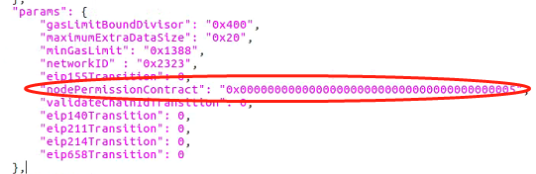

Picture 1

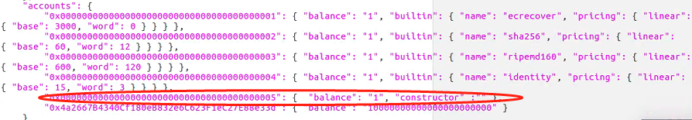

Picture 2

### Write the network layer permission smart contract

The smart contract can be downloaded from:

<https://github.com/onebit256/poa/tree/master/premissioning_contracts>

Code Explanation:

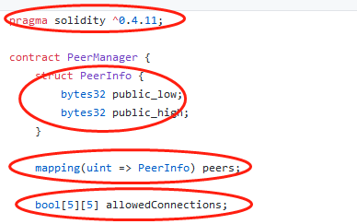

1. Specifies the solidity version
2. Struct is a kind of data structure in Solidity language, and we can customized our data structure using this data type.
3. Mapping is a kind of data structure in Solidity language, it is analogous to dictionary in other languages. Key and value pair
4. Array is a kind of data structure in Solidity language. Like arraylist in other languages

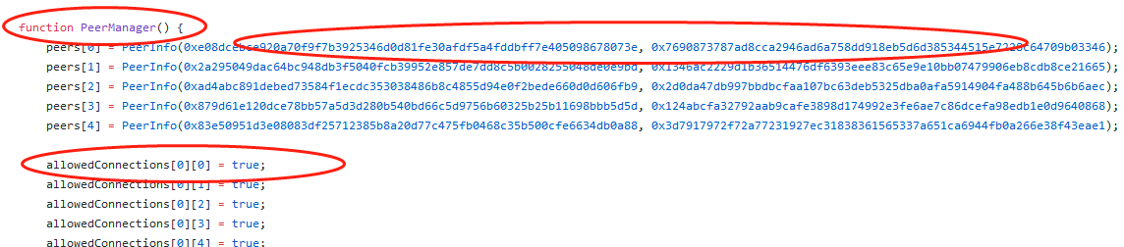

1. peerManager is the constructor of this contract. Constructor is used to initialize the smart contract
2. The EVM architecture allows 32 bytes words. As enodes addresses are 64 bytes long, they need to be cut in two parts for a smart contract to handle them. For example the enode enode://841015562d43c8037b127ee2a89f861d39beb468fecab72ad4bf369d3db8a01a5adeee0e0422cb021acea7ffeb0516db9e1211510ad353dc353b8c52165003c8 would be represented using :

* sl: 0x841015562d43c8037b127ee2a89f861d39beb468fecab72ad4bf369d3db8a01a
* sh: 0x5adeee0e0422cb021acea7ffeb0516db9e1211510ad353dc353b8c52165003c8

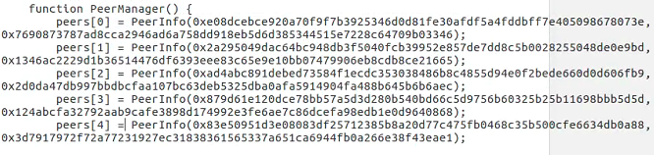

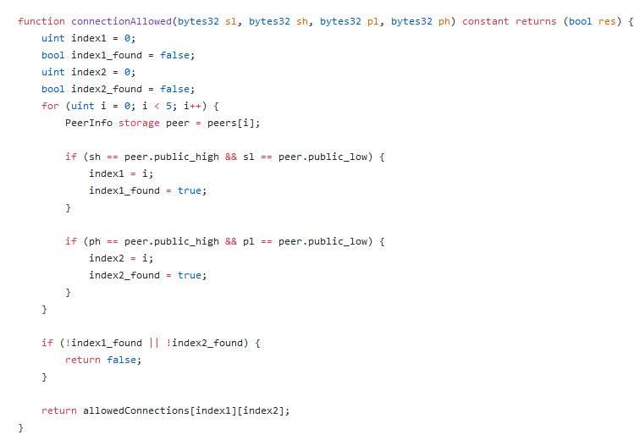

It fetches data from the list, and return true or false to allow or disallow the connection between 2 peers

### How to obtain Bytecode?

1. remix

<https://remix.ethereum.org/>

There are two ways to use remix:

1 use remix to write smart contract

2 use remixd to connect with the local files

3 use truffle compile

**1 use remix to write smart contract**

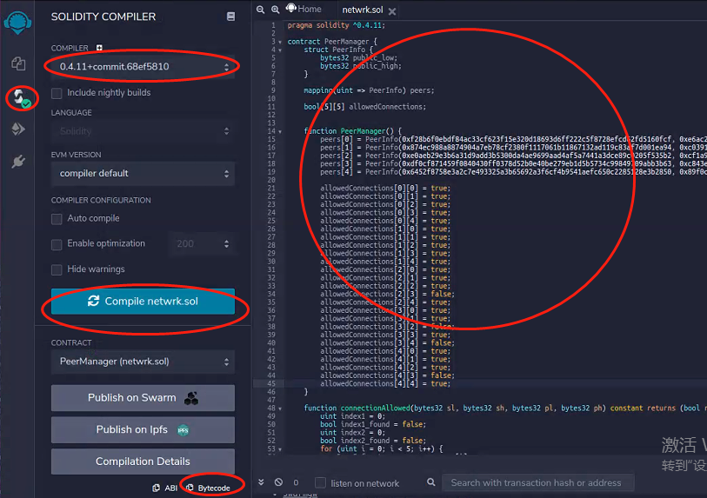

1. Create a new file and write smart contract on it
2. Go to compile panel and select the solidity version
3. Click compile button
4. Click Bytecode, and copy the bytecode to a text editor

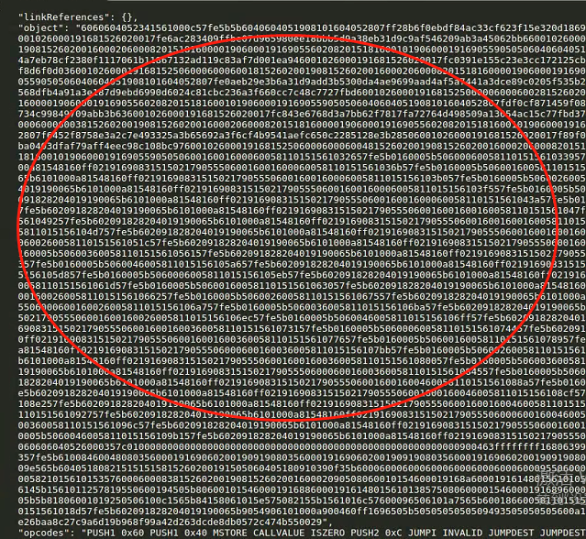

You will get something like above, only take “object” part from 606.....0029, and add 0x in front, and paste that to constructor



**2 use remixd to connect with the local files**

**2.1 Install remixd:**

npm -i remixd

**2.2 Init truffle:**

mkdir testper

cd testper

Truffle init

Ls

Cd contracts

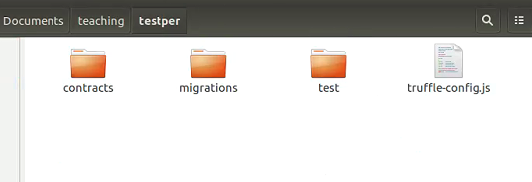

You will see truffle auto generates contracts folder, migrations folder and test folder

Usage of these folders:

Contracts: use to store the contracts

Migrations: use to store all the contract deployment js files

Test: use to store the unit test js file

Truffle-config.js: use to write the configuration for the smart contract

**2.3 write peermamger smart contract and store it to contracts folder**

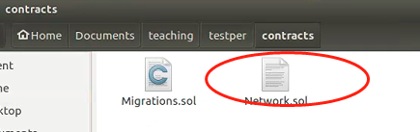

**2.4 Start Remixd:**

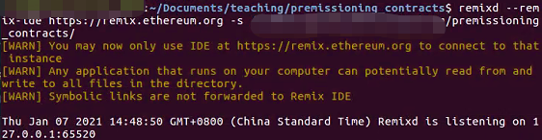

Type remixd --remix-ide <https://remix.ethereum.org> -s (absolute path of your truffle project directory)

In our case, it should be

remixd --remix-ide <https://remix.ethereum.org> -s /home/root/Documents/teaching/testper/

After you press enter, you should see above console log, it mean the program is monitoring 127.0.0.1:65520 port

2.5 Go to remix plugin and click remixd

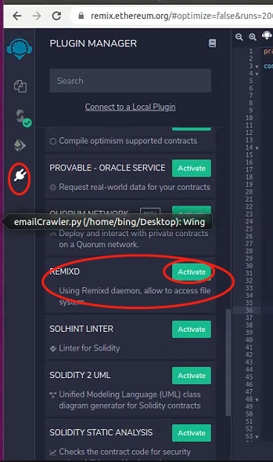

Click plug button

Click active

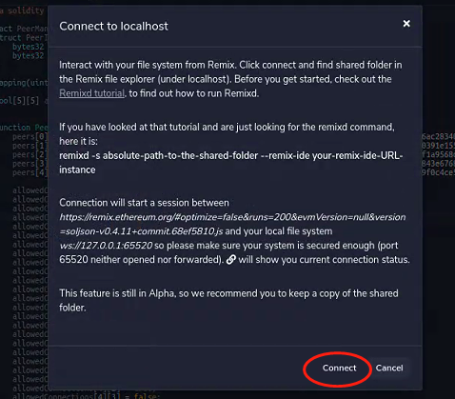

It will pop up this window, then click connect

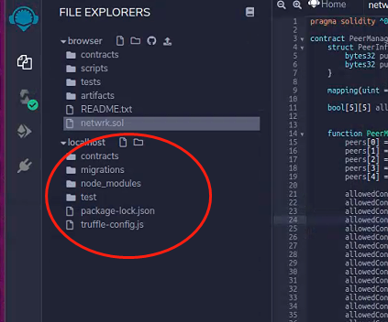

Then you will see your local host files have been mapped to this remote remix ide

Then repeat the same compilation process and get byte code

1. **Truffle**
   1. **download vscode and import truffle to vscode**

3.1 config truffle-config.js

1. Comment this out and hard code the mnemonic



1. Comment private out and set the rpc url to be http://127.0.0.1:8540

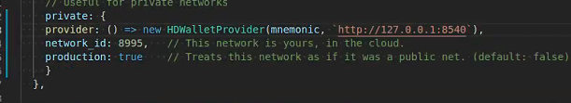

1. add the right solc version

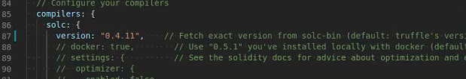

1. Install hdwallet-provider

Npm i @truffle/hdwallet-provider

Then open a terminal and type:

Truffle compile

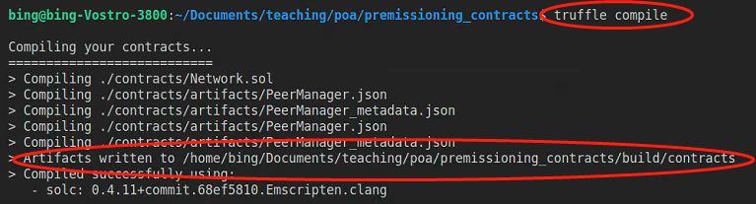

You will be able to see the above console log.

All the compiled files are stored in build/contracts folder

1. Go to build folder, then open compiled peermanager.json to obtain the bytecode

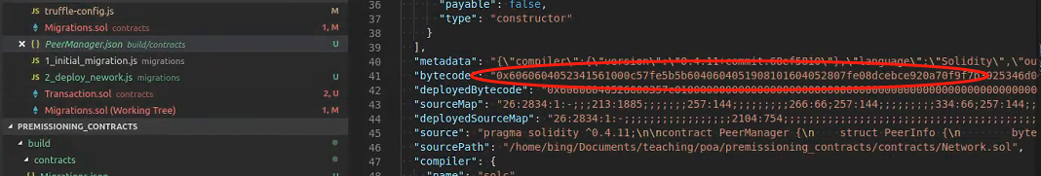

### 1.1.3 Test if network authorization works

1. Start a 5 node network with demo-spec.json and test if they are connected by looking the block # hash

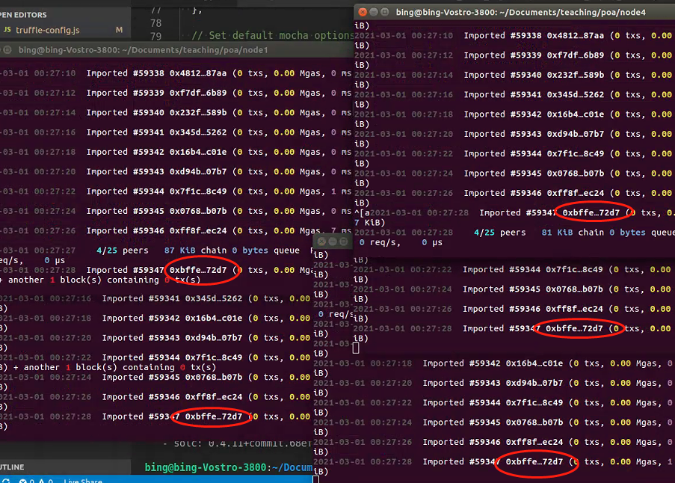

They all connected

1. Create a new demo-spec-np.json and add compiled bytecode to constructor





Then start the 5-node network with demo-spec-np.json and check the connected peer numbers

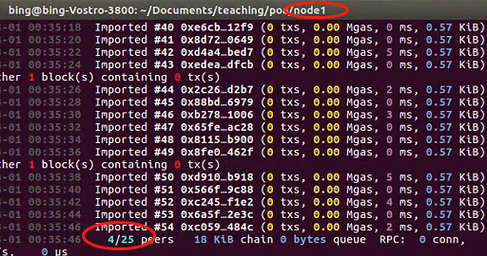

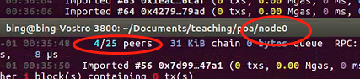

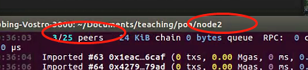

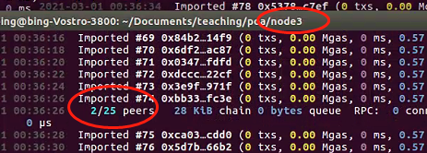

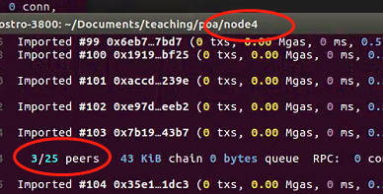

This result is what we expected, if we compare it with the code



## Transaction Layer Permission

**1.2.1 code explanation**

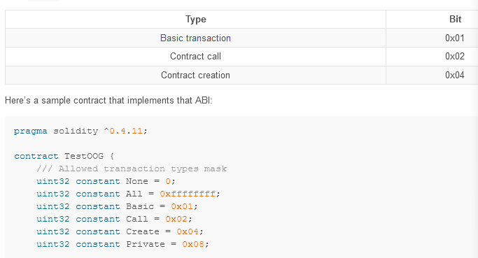

Compile and put the bytecode and address to chain spec

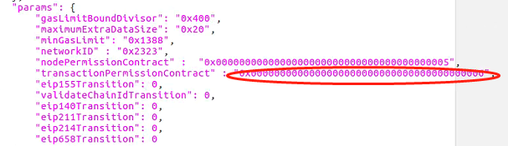

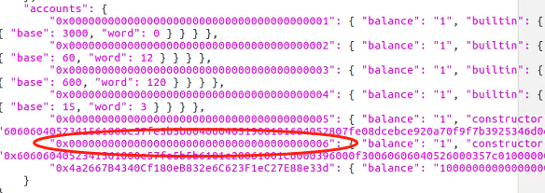

**Test:**

Truffle migrate --reset

Truffle migrate --network private t test if a account can deploy contract

transfer

## 1.3 Validator Set

### 1.3.1 How to upgrade smartcontract(smartcontract is not immutable)

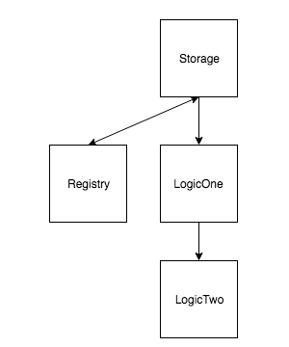

Code:

<https://github.com/onebit256/Upgradable-Proxy-Smart-Contract>

Call functions in Registry to invoke functions in LogicOne / Two

**Code Explain:**

Function() fallback function, when someone send ETH to this contract without providing data or someone try to call function doesn’t Exit

Solidity Assembly language

**Simple illustration of upgradable smart contracts**

Truffle migrate --network private

Truffle console

Let regi = await Registry.at(Registry.address);

regi .setLogicContract(LogicOne.address)

Let log1 = await LogicOne.at(Registry.address);

Log1.setValue(2)

Homework：

1. Set Current Logic contract in Registry

Registry.at(Registry.address).setLogicContract(LogicOne.address)

1. Check logic_contract address in Registry

Registry.at(Registry.address).logic_contract()

1. Update Registry storage from LogicOne

LogicOne.at(Registry.address).setVal(2)

// Check value: value should be 4

LogicOne.at(Registry.address).val()

// check owner val

Registry.at(Registry.address).owner()

1. Change logic layer to LogicTwo

Registry.at(Registry.address).setLogicContract(LogicTwo.address)

1. Set LogicTwo new value

LogicTwo.at(Registry.address).setVal(2)

// check value: value should be 6

LogicTwo.at(Registry.address).val()

1. LogicOne should still be able to set the val

LogicOne.at(Registry.address).setVal(2)

// check value: value should be 6. WHY?

LogicOne.at(Registry.address).val()

**Comparing this example with Validator Set**

<https://github.com/onebit256/kovan-validator-set>

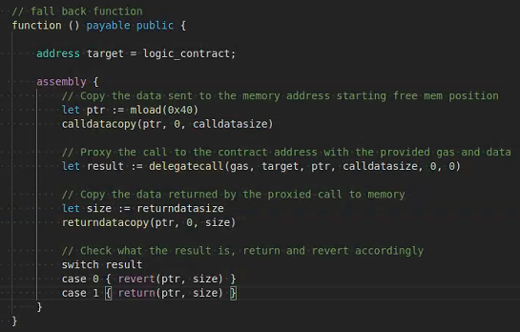

Delegatecall: call other function

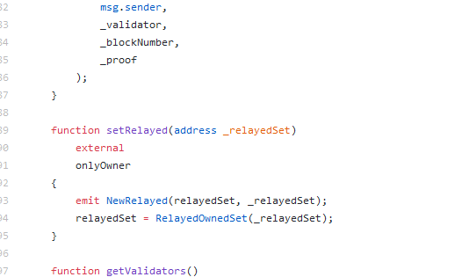

Create an instance of the logic contract in proxy contract

Set ValidatorSet by Contract

